Institution's Innovation Council
Saurashtra University

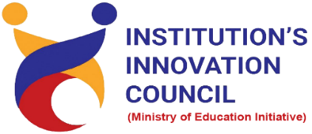

Out of the box thinking for problem solving
28th June 2022
At
Virtually on YouTube

Contents
Saurashtra University – IIC 3
Event Schedule 3
Brief about Event 4
Key Points 4
Outcome 4
About the Speaker/Chief Guest 5
Connect Us: 6

Saurashtra University – IIC
The university is dedicated to instruction, research, and extending knowledge to the public (public service). Ministry of Education (MoE), Govt. of India has established ‘MoE’s Innovation Cell (MIC)’ to systematically foster the culture of Innovation among all Higher Education Institutions (HEIs). The primary mandate of MIC is to encourage, inspire and nurture young students by supporting them to work with new ideas and transform them into prototypes while they are informative years. Saurashtra University is one the Organization that have constituted the IIC to foster the vision of MoE and be a part for the promotion and development of innovation ecosystem.

Event Schedule

02:00

Welcome

02:05

Awarness Session

02:45

Q n A

03:00

Closing Ceremony

Brief about Event
Organizes Session on "Out of the box thinking for problem solving" 28th June 2022 at 2.00 PM by Prof. V. Kamakoti, Director, IIT Madras.
In this webinar’s discussed about Out of the box thinking through Mathematics with examples. Webinar’s benefits are to gain insights about solution of the problems. Also, understand how to think differently and how to solve problems differently was made understood by the speaker.
Webinar’s objective is to identify the problem and address it with systematic and Innovative solution. To understand the connectivity between the solution and problem which is inevitable. To enhance thinking skill and to find out the methods and ways for establishing entrepreneurship by applying innovative solution.

Key Points

During the session, below mentioned points were discussed:
- Cultivating a different way of thinking
- 4 levels of the course
- Examples of Apple – Knife – Stone
- Brain for innovative thinking
- Importance of numbers and alphabets
- Game for mathematics
- Think differently for problem solving
- Education based on stories and examples like “Patti and Pongal”
- FAQs related to Out of the box thinking for problem solving

Outcome

As per the event, the participants were able to understand the basic concept of innovation for problem. various types of examples of problem solving given by the speaker.
Also, as it was related to understand how the innovative thinking helps to solve the problem and also to enhance entrepreneurship in business world.

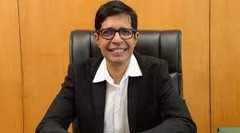
About the Speaker/Chief Guest

Prof. Kamakoti Veezhinathan

Professor at IIT Madras
Chennai, Tamil Nadu, India

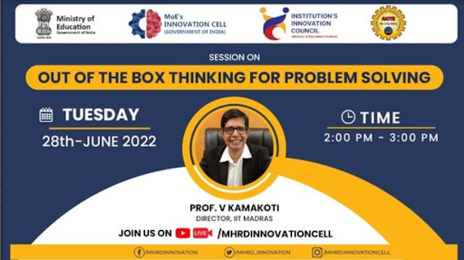

.

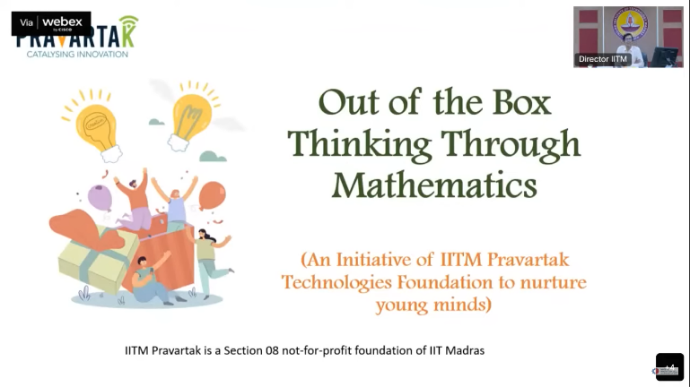

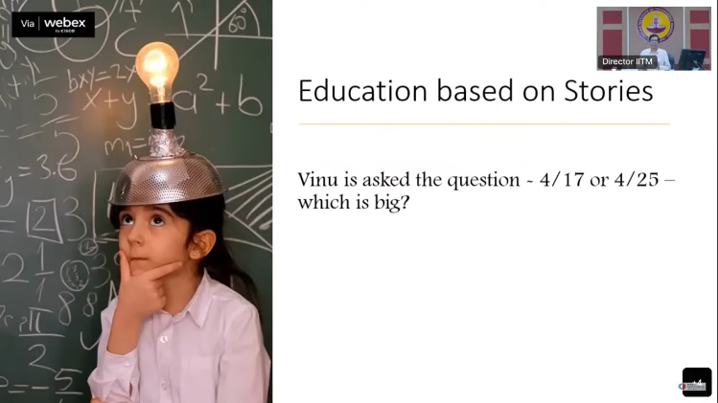
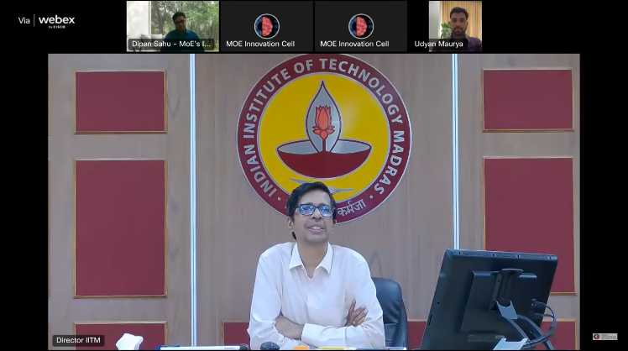
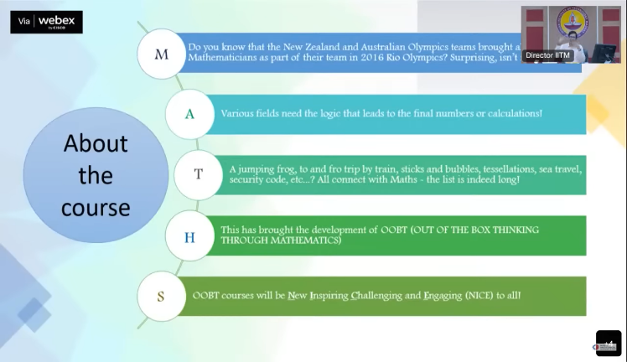
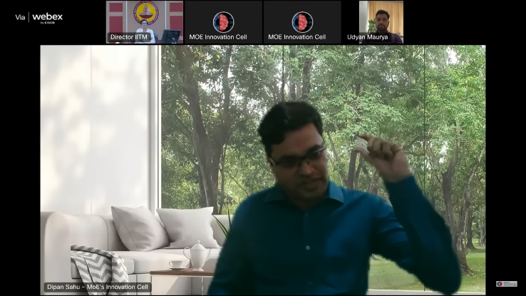
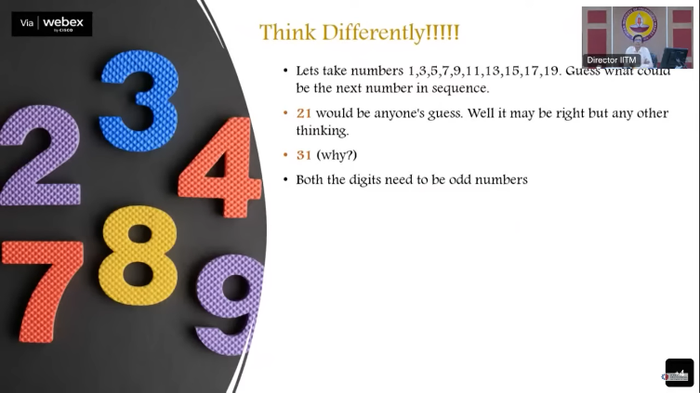

Connect Us:

https://www.linkedin.com/company/susec iic@sauuni.ac.in
https://www.facebook.com/iicsauuni bit.ly/SU-SSIP Location
https://www.instagram.com/susecrajkot https://bit.ly/SUSEC-youtube

